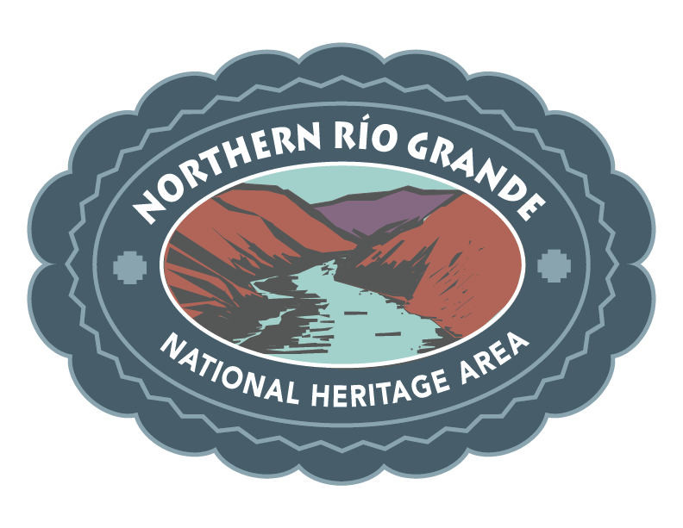
CALL FOR ARTIST SUBMISSIONS

The Northern Río Grande National Heritage Area has always served as a responsible steward and advocate for the preservation of the culture, heritage, language, and environment in Northern New Mexico, and through an increase in efforts we have been working collaboratively through outreach and continued cultural education to increase economic growth, awareness of our shared heritage, and community advancement.

As a proactive advocate for preserving the culture, heritage, and natural resources in the Northern Río Grande area, we are increasing awareness and working for economic expansion to ensure that the culture, heritage, and environment are preserved for future generations.

Artists who have work that emulate the following themes are encouraged to submit their designs for a commemorative 2024 Cultures and Creators Visual arts poster. Selected artists will receive a licensing fee of $500 in exchange for reproduction of the artwork in print, web, and social media. Artists whose work is included in the campaign will also be featured as Cultural Ambassadors for our Cultures and Creators Visual Arts Festival and featured prominently on the website and in our social media platforms.

Project theme:
Our Ancestors. Our Future.

Work that carries overtly political themes is not appropriate for this campaign. We are looking for work that celebrates the culture, diversity, and vibrancy of our communities within Northern New Mexico.

To submit your work, send up to five (5) images (.jpg preferred) no larger than 1mb in size to conner@riograndenha.org before July 1, 2024

